

How to be included in
Orleton Village Magazine

This magazine will be published on the first day of each month on the Village Website: www.orletonvillage.co.uk. Notification of publication, together with a link, will be given on Nextdoor and Orleton Village Chat (Facebook)

Articles of general interest, club or association reports and advertisements for community events may be included without charge. Commercial advertisements are charged, dependent on size. (Rates available on request from: orletonmagazine@gmail.com)
Small private sale advertisements may be accepted without charge if space allows
Orleton Village Hall

Ideal venue for family events, parties, weddings, concerts, dances,
training courses, drama performance, exhibitions, classes and craft fairs.
Large hall (160 seating capacity) with proscenium stage, theatre lighting and sound system, electric piano, video projector and radio mike.
Additional small hall (50 capacity)

Superb five star rated kitchen, cutlery and crockery. Large car park.Free Wi-Fi

Also tables, chairs and marquee available for hire for garden parties

For bookings /quotations: bookings@orletonvillage.co.uk
Tel 01568 780583

All content is accepted at the discretion of the editorial team. Articles that are disrespectful or prejudicial will not be accepted.

Copy should be submitted as Word or PDF files. If hard copy is submitted there may be a charge for scanning and input.

All copy must be accompanied by the name, address and telephone number of the author, although this will not be included unless incorporated into the article.
Articles for publication should be emailed to: orletonmagazine@gmail.com by the 25th of the month prior to desired publication

Editorial

Orleton Village Hall
Ideal venue for family events, parties, weddings, concerts, dances,
training courses, drama performance, exhibitions, classes and craft fairs.

Large hall (160 seating capacity) with proscenium stage, theatre lighting and sound system, electric piano, video projector and radio mike.
Additional small hall (50 capacity)

Superb five star rated kitchen, cutlery and crockery. Large car park. Free Wi-Fi

Also tables, chairs and marquee available for hire for garden parties
For bookings /quotations: bookings@orletonvillage.co.uk
Tel 01568 780583

This Summer has kicked off with the July Orleton Fete, which attracted a large number of residents and visitors who were able to enjoy a range of stalls and entertainment, all provide by a volunteers from our community. If you were not involved and would like to participate in future community events, even if only in a small way, please email your details to this magazine. See below.

This event will be followed up in August by a visit from our regular guests, members of the Van Club. Last year their focus was a Barn Dance, restricted to members, but this year the highlight will be a Craft Fair and Farmer’s Market on 30th August, featuring their members, but also open to Orleton residents as both stall holders and visitors. Stalls (£15) can be booked at Christa@thevanclub.co.uk.

If that is not enough excitement for one day the Maidenhead are holding their Summer Festival of music, children’s activities and more, also on 30th August. See the advertisement for further details.

Looking further forward to the Autumn we will be welcoming the renown Ludlow Concert Band. This large band produces an amazing sound and covers classics, songs from the shows and popular music - something for everyone. They will be appearing at the Village Hall on 19th September and tickets are already available at Orleton Village Shop and Post Office. Book early to avoid disappointment.
Orleton Village is a home to a wide variety of talents, many of whom may not be confident in providing an evening of entertainment on their own, but what would be fantastic is if these talents could be brought together for a cabaret evening with each providing a small example of their musical skills.

This is something which we would wish to develop during the coming Winter. If you have a talent to provide, say 20 mins of musical entertainment as part of a selection of acts for an evening cabaret entertainment, please email this Magazine.

Email to: orletonmagazine@gmail.com



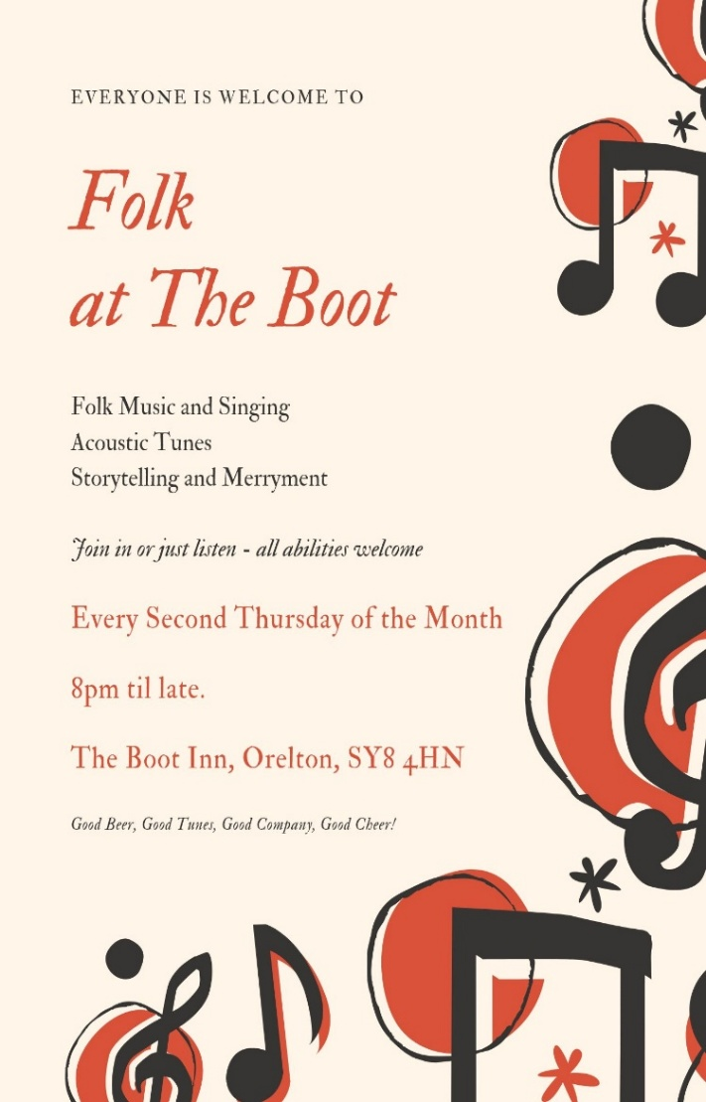



Orleton Evergreens



Our 2026 programme is well under way:

The next few months see us out and about:

August 27th Outing to Gloucestershire & Warwickshire Steam Railway, Cheltenham £37 (£39 non members)

ALL WELCOME

Further details: sue.a.turner@gmail.com 01584 831324

Orleton History Group

The History Group took a break for the summer holidays in July, so our next talks are on:

Saturday 29th August at 2.30pm, St George’s Church: Linda Crichton, a Hereford Tour Guide, will present a discussion of iconic buildings in Hereford City Centre that reflect different periods of development and styles of architecture through the centuries from Medieval, Jacobean, Georgian to Victorian. Some you’ve seen, some may hold a few surprises!

Saturday 26th September at 2.30pm, St George’s Church: following his very popular talk on PTSD last year, Peter Naish returns to talk on his favourite topic of hypnosis. Believe it or not, hypnosis has been around since the time of the Ancient Egyptians. Down the ages the effects have been ascribed to the power of the gods, to magnetism and to . . . well a denial that there are any effects! Now you can come and hear the history and the truth. By the way, Peter promises he won’t make any of the audience come to the front and behave like a headless chicken or the like!

Saturday 31st October at 2.30pm, St George’s Church: Orleton on the edge: discover the fascinating story of how Orleton (and St George’s as part of this) seems to have always had an uneasy relationship with Leominster and the Priory. John Berry and Liz Mackay will explore how, rather than sitting contentedly under the control of Leominster and the Priory, Orleton seems to have often trodden its own path, often putting it in the midst of power struggles between Church (represented by the Priory) and State (represented by the powerful Mortimer lords, who were lords of Orleton).
You can read reports on previous talks at the history group page at: www.stgeorgesorleton.org.uk (and then click on ‘Orleton History Group’). You can also find, at the same web address, the reports on the research undertaken so far into the lives of the men on the Orleton War Memorial.
If you would like further information about the group, please contact Liz Mackay on e.e.mackay@gmail.com, or 07484 679671.


0rleton Art Group

Are you artistic or do you fancy trying your hand at painting and drawing? If so come and join us. We meet Wednesday afternoons from 2.00 until 4.30pm at Yarpole Village Hall.

For more information, please email Larry Turner, laurencepturner@gmail.com
or Geoff Trotter, geoffrey.a.trotter@gmail.com

Or telephone Larry on 01584 831324









We just wanted to say a huge thank you to everyone who helped make the Orleton summer fete a wonderfully fun, friendly, community event. In addition to having a super day, we even raised just over £3000, to be shared between the Village Hall, Recreation Association and St George’s Church.
Thank you to everyone who came, took part, ran stalls, donated items, cooked food, baked cakes, set up, tidied away, kept everyone supplied with cups of tea, got drenched in the stocks, played music, organised dogs shows, maypoles, fire service, police cars, etc. etc. We realise we are in a danger of this becoming Oscar speech and it isn’t possible to mention everyone and all the jobs people did, or we would take up the whole of this magazine.
.
. So, thank you very very much to everyone involved.
Here’s to another wonderful day next year!
And just because it’s never too soon to think about next year (the planning begins now): if you have any thoughts about next year’s Fete, please get in touch with one of the Festivals Committee: John Berry, Sara Burnham, Sue Copson, Nicki Gunn, Liz Mackay, Claire Morgan, or Marj Pritchard
(The Festivals Committee works together across the Recreation Association, Village Hall and St George’s Church to put on four big events for the village each year – the St George’s Festival, the Fete, the Harvest Festival & lunch, and the Stars & Angel Festival)

Orleton Craft Group

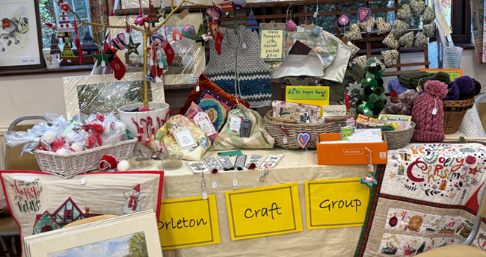

We meet on the first and third Thursday afternoons in Orleton Village Small Hall, £4 per session.

Our Crafternoons run from 1:30 to 4:30, bring along whatever you are working on, enjoy friendship, chat, tea and cake!

HIDDEN GARDENS OF HEREFORDSHIRE

On 30th June we welcomed back Alun and Jill Whitehead, proprietors of Aulden Farm, a three-acre informal country garden planted with wildlife in mind. Aided by a delightful slideshow Alun and Jill took us on a whistle stop tour of twenty-seven of Herefordshire’s gardens, large and small, some well-known, others less so.
In early Spring snowdrop displays can be found at Ivycroft, a small nursery specializing in unusual plants, the National Trust’s Weir Garden and Lyndalls, a twenty three acre garden boasting a lake as well as one of the finest snowdrop collections in the county.
Later in the year The Old Rectory at Thruxton has a fine collection of irises, there are tulip and camassia meadows at Titley Mill followed by roses. Old roses drip romantically from the ruined walls of Wilton Castle with a pretty garden surrounding the adjoining manor house.
Interesting water features are found at Bryan’s Ground, a remodeled Arts and Crafts garden, with its serpentine edged canal and follies, The Court of Noke at Pembridge with its C17 garden and T-shaped canal and Lawless Hill, Sellack, a garden with a Japanese ambience and an infinity pool. The charming half timbered village of Eardisland has its own collection of gardens by the river Arrow, including Glan Arrow with a herringbone haha and white garden.
The houses are also of great interest, varying from cottages to Victorian and Arts and Crafts buildings. Perrycroft, Malvern, is an Arts and Crafts house designed by CFA Voysey. Although not a garden designer Voysey’s houses were designed to blend seamlessly with their gardens. He designed the benches and gates at Perrycroft as well as the internal fittings.
These gardens are a taste of the hidden delights revealed by Alun and Jill. A list can be found on the Club’s website.
Ghislaine Arundale
On August 15th we will hold our 45th Annual Show at Orleton Village Hall. See our website for more details of classes and timings. Viewing and Refreshments from 1.30 pm.
www.orletongardeningclub.co.uk

Community Safety

Ride Along Scheme

Have an interest in policing?

Thinking of a career in policing or simply wish to find out more about what we do?

Our Ride Along Scheme gives you an opportunity to follow a police officer on shift.

The aim of the scheme is for us to strengthen relationships with the public and help people understand more about what we do and how we police.

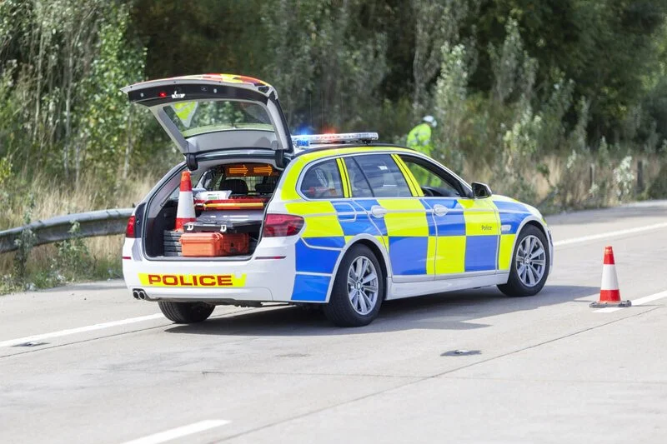

In-Person Ride Along

You will accompany a local neighbourhood officer on patrol and experience first-hand their work to resolve issues or concerns in the local area. You'll get an insight into what it’s like to be a police officer on shift and an opportunity to experience an unrivalled view of front-line policing.

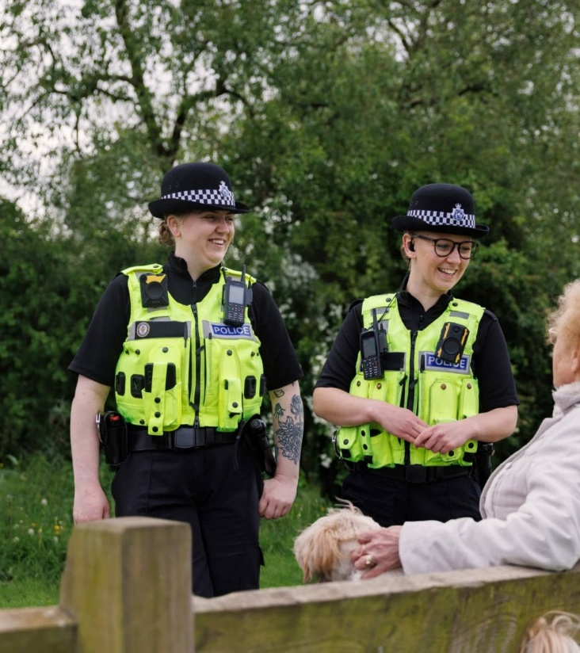

Virtual Ride Along

Our Virtual Ride Along Scheme lets you follow an officer’s shift remotely through live body-worn video, offering an accessible way to see policing in action from a police station.

It provides a unique insight into how officers handle incidents and make decisions, while allowing more people at once to experience neighbourhood policing in a safe and controlled environment.

Who is the scheme open to?
- anyone aged 18 or over, and
- lives in Herefordshire, Shropshire or Worcestershire
See our website
www.westmercia.police.uk for more details.


C

August Coffee Mornings
in St George’s

With the regular Wednesday weekly Coffee Shop in the village hall taking a well-deserved rest during August, we invite you to join us in St. George’s Church between 10.30 and 12 noon for coffee/tea and cake.

5th, 12th, 19th and 26th August

People of all ages are welcome.

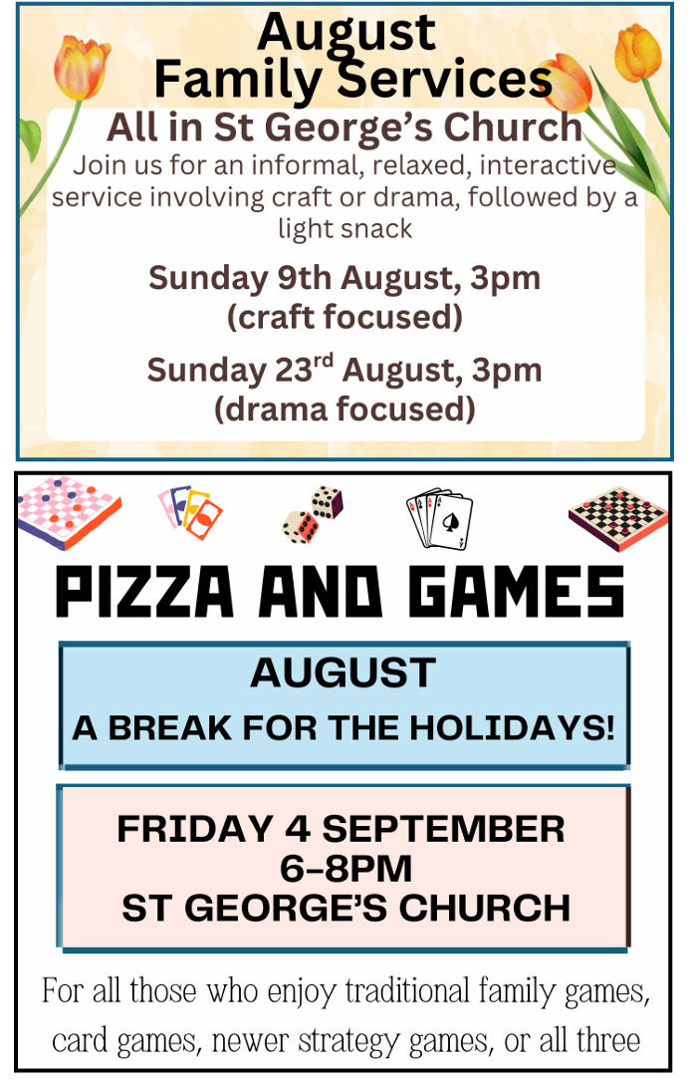





Orleton Charity Quiz Nights

November 16th Village Hall
December 8th Maidenhead
September 8th Maidenhead
October 13th Boot Inn

Teams of up to six members. 7.30 for a 8.00pm start
Pre-booking of tables at:
the Boot (01568 780228) and the Maidenhead (01584 831686)
is strongly advised
All proceeds go to support local organisations in Orleton Village or
recognised National Charities.
Special Event: John Robbins Memorial Quiz at Orleton Village Hall
on a Saturday evening. Watch for the date!









Orleton Village Shop & Post Office

Shop Post Office
Mon- Fri 0745-1800 0745-1800
Sat 0830-1230 0830-1230
Sun 0830-1230 Closed


Grafted Apple trees
2-3 year old named dessert, cookers, cider varieties
In pots - £20 (discount for bulk)
Trees in pots are easy to look after until
you’ve decided where to plant them!
Discovery, Ashmead’s Kernel, Russets, and many more...
Root stock: M25 vigorous; M111 & MM106 semi-vigorous
Advice on tree/orchard management also provided
Contact Chris, 07939 864732
Waterloo Farm, SY8 4JG
applewoodcourses@yahoo.com
www.applewoodcourses.com





Orleton Good Neighbour Scheme

The Good Neighbour Scheme supports our community using a team of volunteers to help people who are experiencing difficulty in their own homes essentially, by just doing things that good neighbours do for each other.

Examples of how the scheme can help:
- Fetching prescriptions
- Occasional lifts to the surgery or hospital
- Shopping and running errands, such as posting a letter.
- Practical tasks around the home, such as changing a light bulb or hanging a picture

- Contact Number 07467 535503



Victoria Allen Funeral Services
(Est 2006)

An Independent Family Business

Private Chapel of Rest

Pre-Paid and Pre-Arranged Funeral Plans

Covering All Areas

Home Visits Always Available

24 Hour Service

Victoria Allen
8 Charlton Rise, Ludlow, Shropshire, SY8 1ND
01584 879035

Graham Bradley
6 Orchard Close, Kingsland, HR6 9QS
01568 708022

Email: vafs@btinternet.com
www.vallenfuneralsludlow.co.uk



Advertising in this magazine

Club and association events
and other activities open to local residents – FREE

Commercial advertisements
Half page £20 per year
Quarter page £15 per year

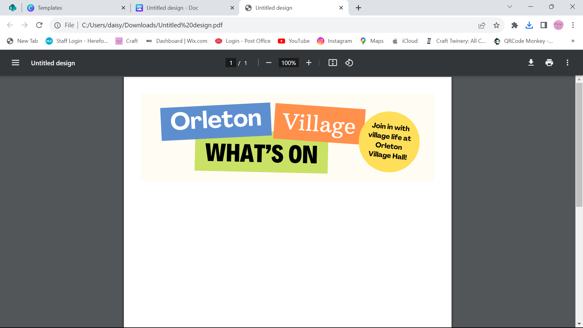
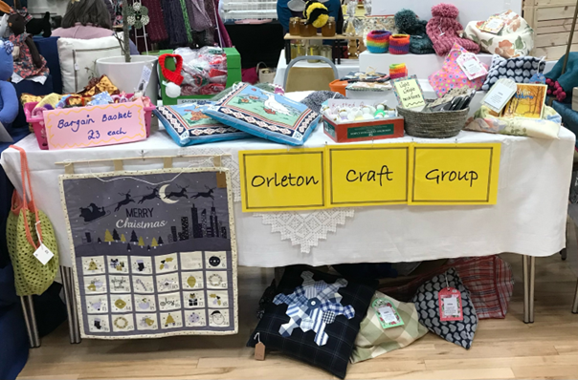



Orleton Village Hall has regular weekly activities to which new members are always welcome. Contact details can be found here…

Monday’s
Orleton Toddlers Every Monday morning 10-11:45am
Contact: Bethan 07534 726222 or Charlotte 07964 981036
Orleton WI 2nd Monday of the month, October to March at 2:30pm
Contact: Sue Copson susancopson934@gmail.com
Tuesday’s
Rainbows Every Tuesday in term time 4:30-5:30pm
Contact Kaye Harrison kayemharrison@yahoo.co.uk
Orleton Ramblers 2nd and 4th Tuesday of month - Meet at Village Hall 9:50am, leaving at 10:00am
Contact: Jan Greatrex tandjgreatrex@gmail.com
Gardening Club Last Tuesday of the month 7:30-9:30pm
Contact: Monica 01568 613861 orletongc@hotmail.co.uk
Yoga Every Tuesday evening 6:30-7:30pm (Commences again in September)
Contact Rosie 07834 851656
Wednesday’s
Coffee Morning Every Wednesday at 10:30am-12:00 (Closed in August)
Contact: Cathy Hardwick cathy.hardwick@hotmail.co.uk
Library Last Wednesday of the month at Coffee Morning 10:30-11:45am
Contact: Sue Rogers 01584 831514
Sequence Dancing 3rd Wednesday of the month – 2-3pm
Contact: Amy Whitby amyelwynwhitby@gmail.com
Thursday’s
Evergreens Last Thursday of the month – 2-4pm
Contact: Sue Turner sue.a.turner@gmail.com
Craft Group 1st and 3rd Thursday of each month 1:30-4:30pm (No sessions in August)
Contact Sue Turner 01584 831324 sue.a.turner@gmail.com
Table Tennis Every Thursday at 7:30pm
Contact: Geoff Lewin geoffnlewin@gmail.com

Orleton Village Hall is available for private bookings
Contact Barry Gandy 01568 780583 or bookings@orletonvillage.co.uk

All entries are, as far as we know, correct at the time of going to print.

Contacts

Allotments Assoc | Nick Ford |  | 01584 875834
Art Group | Geoff Trotter | Geoffrey.a.trotter@gmail.com
Caring for God’ Little Acre | Barbara Mark |  | 01568 780842
Church Wardens | Liz Mackay  John Berry |  | 07484 679671  01568 780321
Doctors |  |  | 01584 831300
Evergreens | Sue Turner | sue.a.turner@gmail.com | 01584 831324
Gardening Club | Nick Russel |  | 01568 780678
Good Neighbour Scheme |  |  | 07467 535503
Herefordshire Councillor | Cllr. Dan Hurcomb | dan.hurcomb@herefordshire.gov.uk | 07792 882147
Land Drainage Group | David Lane |  | 01568 78036
Orleton Footpath Maintenance Volunteers | Martin Bradford | emlmart@hotmail.com | 01568 780151
Orleton Relief in Need | Barry Rogers |  | 01584 831514
Orleton Junior Football Club | Mel Williams | cherry.brook@me.com | 07511 920515
Orleton Toddlers | Bethan Jenkins | Bethan.I.edwards@hotmail.co.uk | 07534 726222
Orleton Young Farmers Club | Bell Beaumont | orleyonyfc@hotmail.com
Parish Council |  | clerk@orleton-pc.gov.uk
Pre-School | Tara Morris |  | 01568 780143
Primary School |  | admin@orleton.hereford.sch.uk | 01568 780366
Primary School PTA | Nicola Goodman | nicolagoodman1989@gmail.com
Rainbows | Carly Morgan |  | 07788 236628
Recreation Association | Graham Shaw |  | 01568 780783
Village Hall |  | bookings@orletonvillage.co.uk | 01568 780583
WI | Sue Copson |  | 01568 780956

